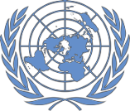NEPAL: COVID-19 Pandemic
Office of the UN Resident Coordinator Situation Report No. 37
As of 21 May 2021

This report is produced by Office of the Resident Coordinator in collaboration with partners. It covers the period from 15-
21 May 2021. The next report will be issued on or around 28 May 2021.

HIGHLIGHTS

• Need for oxygen supplies remains a top priority, including
60,000 cylinders, 2,000 concentrators, 10 tanks, 7 plants and
1,000 high flow nasal canula.

• Requirements for tents and prefabricated structures to establish field hospitals, expand existing hospital capacity and manage returnees at points of entry (PoEs) in advance of the approaching monsoon season.

• Protection monitoring system has identified disruption of family livelihoods and uptake of loans among 79% of vulnerable group respondents.

• Complete unavailability of Antigen RDT tests in Province One means all migrants returning through PoEs in that province are unable to be properly screened.

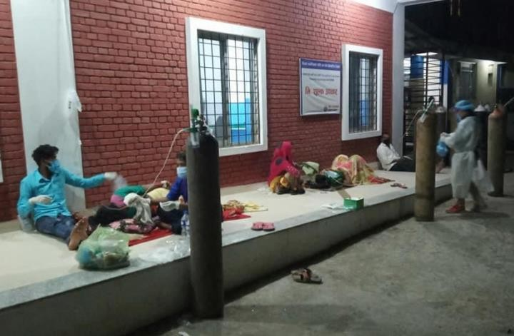
Source: Prakhyat Banjadey
.
• Launch of COVID-19 Response Plan this week, in support of the Government led response.

115,852 | 57,454 | 44.2% | 488,645 | 5,847
Active cases | New cases  (reporting period) | Case positivity | Total cases | Total deaths

SITUATION OVERVIEW

Now three weeks after new prohibitory orders were imposed in Kathmandu Valley (and since in 75 of 77 districts) daily new infections have ceased their exponential growth, but remain between 8,000-9,000 per day. National test positivity has declined slightly over the past week to just over 44%, but is over 50% in four of seven provinces, reaching as high as 59% in Karnali. RT-PCR testing capacity has reached a ceiling, and supplies of testing kits are running low, making re-supply of PCR kits and ramping up of Antigen RDT testing key priorities.

The need for oxygen remains a primary concern, while roughly 3,300 cylinders were received this week from China and Oman, these represent a small fraction of the 60,000 identified as needed by the Government of Nepal. Support for transportation both internationally and within Nepal for refilling is ongoing.

While successful in slowing the rise in infections, prohibitory orders have limited the mobility of humanitarian responders across clusters. Mobility restrictions, as well as prevalence of infection among key staff and service providers have slowed response activities. Access to sufficient PPE and prioritization of these workers for vaccination will be necessary to ensure the continuity of humanitarian work, both during the COVID-19 response and in any potential monsoon related response.

The second wave has hit poor, vulnerable and excluded groups, especially those dependent on daily labor, particularly hard. Women’s groups shared that people are facing increasing fear, disease, mental stress, hunger and starvation and loss of livelihoods in the current context. In support of the Government’s response the humanitarian community launched its COVID-19 Response Plan this week.

PRIORITY NEEDS

Health
• Essential lifesaving commodities, including oxygen supplies (60,000 cylinders, 2,000 concentrators, 10 tanks, 7 plans and 1,000 high flow nasal canula), testing supplies (RT-PCR and Antigen RDT) and PPE.
• Strong need for institutional isolation facilities at the facility level to address patient loads.
• Mobilizing contact tracing and case investigation to break the chain of transmission.
• Critical need for human resources to operate tele-medicine for management of safe home-isolation and information management support for institutions managing public health interventions at all levels.
• Enhanced public health and social measures that ensure universal application.
• Registration, health screening and testing with Antigen RDT for all entrants at all points of entry (PoEs).

WASH
• Installation of new WASH facilities and renovation of non-functional facilities in health care centers, isolation centers and points of entries (PoEs).
• Provision of WASH and infection prevention and control (IPC) supplies to health care providers and sanitation workers in health care facilities, isolation centers and PoEs.
• Technical guidance for local governments on minimum WASH facilities in isolation & holding centers.
• Management of medical waste and dead bodies to prevent infection and environmental degradation.

CCCM/Shelter
• Urgent need for antigen test kits in Province One; complete unavailability of antigen tests is hampering ability to screen returning migrants.
• Upgrade migrant health screening centres at Rani PoEs, including physical distancing and crowd control measures.
• Establishment of health desks at district entry points in Karnali to screening mobile populations.
• Support local governments in establishing and managing temporary holding/isolation centres.

Logistics
• Transport and storage support for MoHP’s and Provincial health services directorates to ensure the timely and
uninterrupted flow of essential, lifesaving health supplies and equipment to health facilities across Nepal.
• Transport for refilling of oxygen cylinders for hospitals in Biratnagar, Chitwan and Dhangadhi.

Risk Communication and Community Engagement
• Clear and contextualized messages using all available communication platforms on mental wellbeing, self-isolation, when to seek care at health centres, and clearer vaccine-specific messaging.
• Outreach to returnees with information on COVID-19 prevention, quarantine need and process, home isolation, available health services including psychosocial counseling at PoEs.

Protection
• Early warning mechanisms must be scaled up, given community networks’ restricted mobility.
• Socio-economic support to vulnerable groups, mainly those in isolation.
• Ensure continuity of GBV prevention and response services and facilitation of mobility and access to PPE and vaccination services to frontline protection service providers.
• Scale up of psychological first aid and counselling support to children, parents and caregivers as well as stress management and self-care sessions for frontline service providers.

Food Security
• Ensure adequate food security and nutrition of vulnerable populations in the most affected municipalities/districts who have lost their sources of income due to COVID-19.

Nutrition
• Provision of supplementary foods for pregnant and lactating women, mainly in isolation centres, and 6-23 months old children in most affected areas of provinces One, Two, Karnali and Sudurpaschim.
• Expansion of outpatient management of severe and moderate acute malnutrition to health posts and via female community health volunteers (FCHV) using adapted treatment protocols.

Education
• Access to self-learning materials for the most disadvantaged children.
• Advocacy to ensure prioritization of vaccination for all teachers to ensure the learning continuity.

Gender in Humanitarian Action
• Dignity kits, PPE sets, first aid kits, medicine, hygiene supplies, food items and PCR testing in shelter homes.
• Transgender sex workers face high risk of contracting COVID-19, as many continue sex work during lockdown, and require vaccination.
• Nutritious cooked meals in government hospitals for front line health workers, ambulance drivers, dead body managers, cleaners who cannot remove PPE to visit canteens.
• Relief and/or cash support for poor households and daily wage laborers.

OPERATIONAL RESPONSE

Health
• Working closely with partners to identify opportunities for support, including capacity building in clinical care, dissemination of IEC materials, development of health bulletins, translating MoHP Incident Command System decisions to actions, development and support to implementation of public health social measures (PHSM) materials, and identification of commodity support for health systems.
• Communication with COVID-19 hospitals and Provincial Health Directorate offices to understand needs and gaps in human resources, risk communication, commodities, and IPC/case management.

WASH
• Provided WASH supplies at five designated PoE serving more than 20,757 returnees.
• Ensured essential WASH facilities in two PoEs and one isolation center.
• Provided cleaning and disinfection supplies and basic protective items to 25 health care facilities.
• Provided 100 hygiene kits to people staying in isolation centers.

CCCM/Shelter
• Provision of NFIs (masks, sanitizer, PPE) to provincial and local governments for distribution at isolation/holding centres, hospitals and PoEs, and distribution of PPE to frontline workers.
• Supporting the livelihoods of low-income households through construction work, duly considering the safety and
COVID-19 preventive measures.
• Support local governments in constructing isolation centres to be used as into emergency centres post COVID-19.

Logistics
• Activated a cargo consolidation/tracking system (Nepal Cargo Flight information) to promote consolidation of essential medical supplies in airlifts to Nepal.
• Continue ongoing support at national and provincial level through the Logistics Cluster: transport, storage at five humanitarian staging areas, provision of equipment (large tents, prefabs, generators), information management.
• Transported 797 oxygen cylinders this week to/from Biratnagar, Chitwan, Dhangadhi for refilling.
• Received 1,950 oxygen cylinders donated from China and 560 from Oman at Humanitarian Staging Area.
• Cluster will transport 800 oxygen cylinders for MoHP to Kathmandu, to arrive 22nd of May at China-Nepal border.
• Initial analysis of oxygen supply chain is that it can be sped up by increasing the number of dedicated staff at MoHP
and by improving coordination & information exchange with oxygen manufacturers.

Risk Communication and Community Engagement
• Queries related to home isolation care, availability of hospital beds and oxygen, COVID-19 symptoms and testing were responded to via hotlines, MoHP media brief and community discussion platforms.
• Engagement with volunteers from Nepal Red Cross Society (NRCS) to reach out to the general public with messages on staying home, public health safety measures, COVID-19 symptoms and testing in high-risk municipalities and at seven points of entry.
• Key messages on mask wearing and hotlines for COVID-19 and child protection are being disseminated through
the social media channels of Bhatbhateni, largest nation-wide supermarket.

Protection
• Protection monitoring has identified access to health care (77%), socio-economic needs (73%) and concerns over mental health (55%) as key issues affecting vulnerable groups. Answers point to disruption of family livelihoods and uptake of loans (79%). Lack of safety and child marriage were highlighted as main issues facing girls while substance abuse and child labour featured among main concerns for boys.
• The current context presents an additional challenge in addressing the needs of children without parental care.
• Psychological first aid and counselling was provided to 302 people (119 male, 183 female) in communities, as well as 1,293 persons at PoE and holding centers over the reporting period.
• A 24/7 hotline service has been operational since the lockdown started on 23 March 2020 to respond to critical protection needs.

• Government has issued directives to district offices for including helpline workers as essential services allowing their mobility during lockdown. Continued advocacy is required for inclusion of social workers, case workers in shelters and psychosocial support service counsellors.

Food Security
• Two mobile Vulnerability Analysis and Mapping and 2-3 market assessments planned, as well as assessments
on disrupted agricultural assets and practices, to monitor the impact on food security, livelihoods and markets and identify immediate needs as well as medium-long term secondary socio-economic impacts.

Nutrition
• Ongoing supplementary feeding programme in Karnali, Province One and Province Two, targeting 6-23 months children and pregnant and lactating women.
• Continue messaging on infant and young child feeding (IYCF), promotion of breast feeding, complementary feeding and nutrition and COVID-19 through the country via FM radio services.

Education
• 3,651 children received self-learning materials in Bagmati and Karnali provinces for home learning.
• Provision of psychosocial support to 40 school children in Province Two.

Gender in Humanitarian Action
• Women and excluded groups organizations, especially those managing women’s shelters, being supported with essential food and medical supplies in Bagmati.

KEY GAPS AND CHALLENGES

Health
• Procurement of essential commodities challenged by a lack of national suppliers and a resulting requirement to import (Antigen testing and specialized equipment for treatment such as oxygen concentrators, etc.).
• Shortage of specialised human resources to support existing human resources and enable operation in a shift system to address facility-based care needs.
• Lack of adherence to public health and social measures at local levels, which are essential to break the chain of transmission.

WASH
• Implementation slowed by lockdown, supply unavailability and infection among cluster member staff.
• Sanitation, cleaning and waste management workers in communities and health care facilities are contracting
COVID-19, leading to disruptions in essential cleaning and disinfection works.
• Isolation centers being established hastily with limited consideration of WASH requirements, thereby increasing chances of infection in isolation centers.
• Management of medical waste from home isolation and institutional centers is a huge issue as there are no strict regulations to guide it. With rising need to manage dead bodies, there are challenges related to pollution of surface and ground water, increasing the risk of additional hazards.

CCCM/Shelter
• Lack of adequate funds to upgrade the infrastructural set-up of health desks and holding centres at PoEs.

Logistics
• Suspension of international flights has delayed the arrival of essential health supplies. However, Government permission for two weekly flights (Qatar & Guangzhou) since 18 May, has reduced this gap.

Risk Communication and Community Engagement
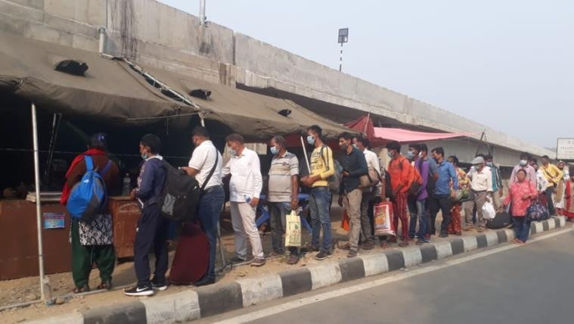• Increased mistrust in the messages shared through different channels.
• Limited face to face interactions of volunteers and

Health desk at PoE, Mechinagar, Province One. Source: IOM/Dwarika Ghimire
.
mobilisers for community engagement due to increased fear of infection, spread of disease and ongoing lockdown.
• Updating skills and knowledge of community volunteers and mobilisers with constantly emerging evidence has

been a challenge for timely dissemination of the messages to the public.
• RCCE coordination at provincial level is a gap.
• Challenges in balancing messages encouraging people to get vaccination versus risk of creating over-demand when supplies are limited/uncertain.

Protection
• The use of some OCMC facilities as isolation wards may impact multi-sectoral GBV response capacity and service continuity (Rautahat and Kapilbatsu).
• Increased fear and reluctance of community psychosocial service providers affects deployment of counsellors.
Psychosocial service reach through other means must be strengthened.
• No outreach services to mitigate the impact of mobility restrictions, constraining access to protection services.

Food Security
• Lack of resources to undertake regular assessments and provide cash/in-kind support to families and farmers.

Nutrition
• Health staff are overwhelmed by COVID-19 response, limiting capacity to deliver essential nutrition services.
• Screening children for wasting constrained by lockdown and lack of PPE for female community health volunteers who run community-based health and nutrition programmes.

Education
• Constraints on printing services, transportation and distribution of self-learning materials are hindering the education of disadvantaged children without access to devices or internet.
• Infection and even mortality among teachers in many municipalities has led to fear and anxiety among teachers, raising concerns that hesitancy to return to classrooms with create further setbacks to education.

Gender in Humanitarian Action
• There is a lack of gender equal and socially inclusive quarantine and isolation centers in all provinces, resulting in specific nutritional, medical, hygiene and accessibility issues of women, people with disabilities and LGBITQ.
• Women, girls, and those from excluded groups have limited access to information.
• Due to prohibitory measures, female sex workers face challenges in meeting their basic needs. Many who do not have legal documents fear they will be unable to access relief.

For further information, please contact:
Prem Awasthi, Humanitarian Coordination Officer, prem.awasthi@one.un.org, Tel: +977 9858021752

